NEW MEMBERS
November 2025

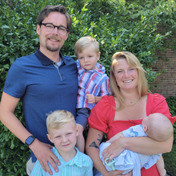
The Beheyts were interested in the Lutheran faith and began worshiping with us at Easter this year. For Cameron and Ashton, the size of our congregation is just right. Their biggest news is welcoming their third son, Owen, at the beginning of June! Weston is 7 and Norman is 3. Cameron is a hearing instrument specialist with Midwest Hearing Specialists for far northwest Indiana, reads music, and is a drummer (but probably he doesn’t play too loud, so as not to damage his own hearing, right?!) As a family, the Beheyts enjoy pontoon boating on the St. Joseph River (they have a dock at their home), playing card games like Uno, camping, and riding bikes.
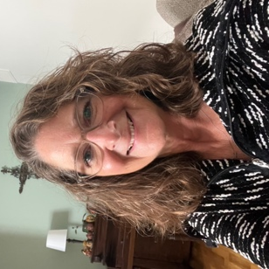
Faith Brummet grew up in Cleveland, OH and is the structure coordinator for Towne Restoration, which provides services after water and fire damage. At her previous church, she shared musical gifts as part of small ensembles and also as a cantor. She enjoys walking, hiking trails, and reading. She and her husband Larry always get excited about the NFL football season (go Ravens!) and enjoy checking out breweries. Fun fact – their son was vicar at the LCMS church in Hickory, NC where Pr. Clark grew up!
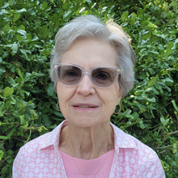
Sheryl Dysert loves the liturgy and sacred music at SPLC and appreciates that we celebrate the Eucharist every Sunday. She’s a former junior high home-ec teacher who devoted her life to homemaking and care for her family. In addition to gardening, birding, reading, and attending symphony concerts, she loves being “Mimi” to her five grandchildren. It’s especially sweet to attend church with her daughter and grandson, and she’s grateful for the warm welcome extended by the pastors and everybody at St. Peter.
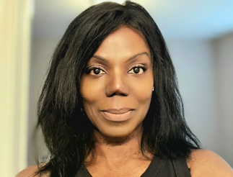
Sonya von zur Muehlen formerly owned her own gluten-free bakery and recently moved to Elkhart from Fort Wayne to take a position with Bimbo Bakery as head of quality and food safety. In Fort Wayne she sang with the Bach Collegium, a professional choral ensemble (and we are thrilled that she has already joined the choir here at St. Peter!). In addition to baking and singing, she enjoys cycling and working out. She’s passionate about women’s ministry activities and appreciates the welcome she’s received at SPLC.
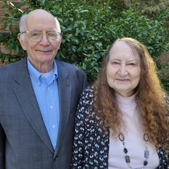
Jim and Diana Pecsi are grateful that their daughter, Roxanne Miller, and her family recommended SPLC so highly, and have appreciated how supportive the congregation is of our young people. Jim was an electrical engineer who started his career as “the tech guy” in the Navy – he says when you’re the only one on a ship who knows how to fix things, you’re pretty popular! He’s also had a lifelong interest in body shop work and car repair, and still maintains vehicles. Diana is retired from human resources and has always done quite a bit of volunteering in church, schools, and the community. Together they are active in the American Legion, sharing meals with friends, and attending grandson Paul’s musical/sports events.

